Project Design Phase
Solution Architecture
Solution Architecture:
Solution architecture is a complex process — with many sub-processes — that bridges the gap between business problems and technology solutions. Its goals are to:
- Find the best tech solution to solve existing business problems.
- Describe the structure, characteristics, behavior, and other aspects of the software to project stakeholders.
- Define features, development phases, and solution requirements.
- Provide specifications according to which the solution is defined, managed, and delivered.
WasteGuide AI — Solution Architecture Diagram:
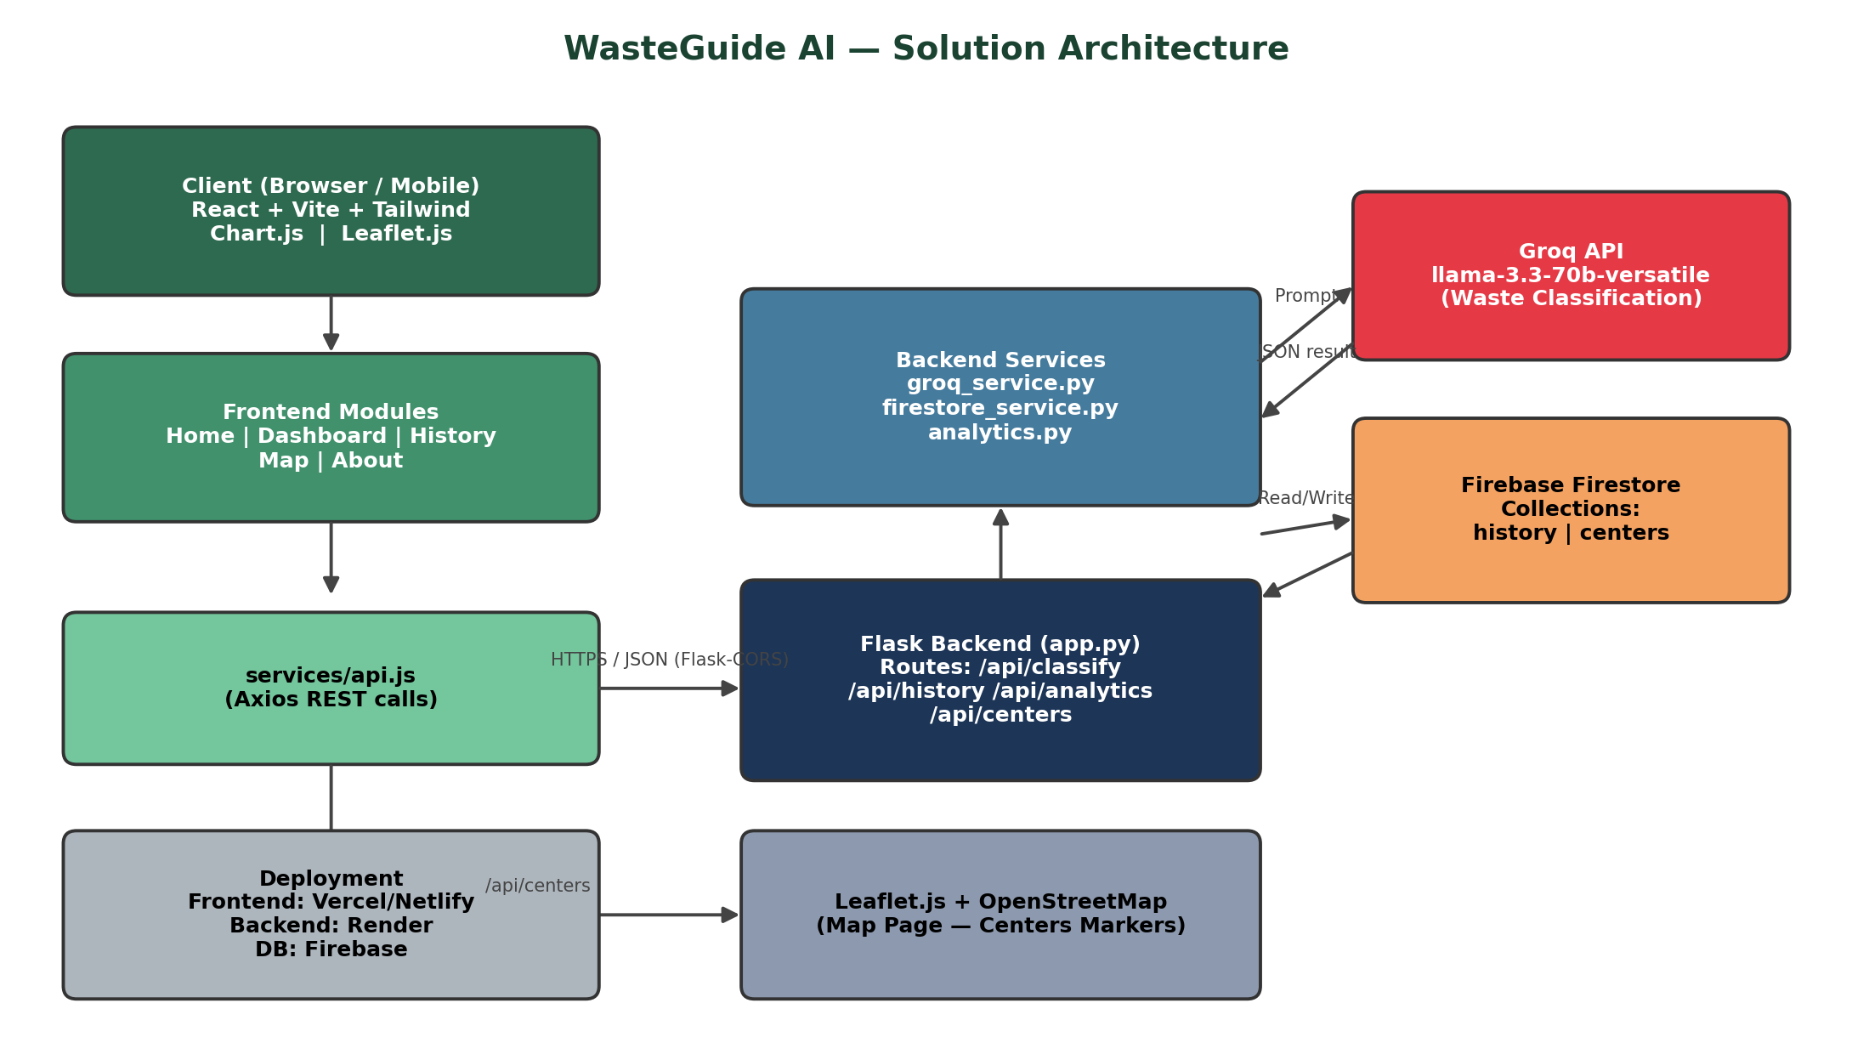
Figure 1: End-to-end architecture and data flow of WasteGuide AI — from the React client, through the Flask backend services, to the Groq generative-AI model, Firebase Firestore, and the Leaflet/OpenStreetMap map layer.
Architecture Summary:
- Frontend (React + Vite + Tailwind CSS): renders Home, Dashboard, History, Map and About pages; uses Chart.js for analytics visualizations and React-Leaflet for the map view.
- API layer (services/api.js): Axios-based REST client that connects the frontend to the Flask backend over HTTPS, with Flask-CORS enabling cross-origin requests.
- Backend (Flask, app.py): exposes REST endpoints — POST /api/classify, GET /api/history, GET /api/analytics, GET /api/centers, DELETE /api/history/<id>.
- Backend services: groq_service.py sends the waste item to the Groq API and enforces a strict JSON response; firestore_service.py reads/writes the history and centers collections; analytics.py computes totals, recycle/hazard percentages and daily trends.
- AI layer (Groq API, llama-3.3-70b-versatile): classifies the waste item and returns category, recyclability, hazard level, disposal/recycling steps and an eco-suggestion as JSON.
- Database (Firebase Firestore): stores the history collection (each scan result) and the centers collection (waste-collection center details).
- Maps (Leaflet.js + OpenStreetMap): plots color-coded markers for recycling, organic, hazardous and electronic-waste centers with popups and directions.
- Deployment: frontend on Vercel/Netlify, backend on Render, database on Firebase — matching the project's deployment-ready folder structure.

